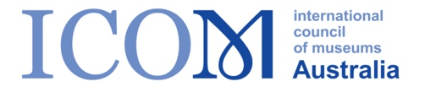
Notice of Annual General Meeting
Thursday 18 May 2023, Newcastle
&
Nomination Form

The Annual General Meeting of the International Council of Museums Australian Committee Incorporated (ICOM Australia) will be held:

12.45 pm - 1.45pm AEST Thursday 18 May 2023
Newcastle City Hall, Mulubinba Room, Newcastle, 2267

Nominations for the Executive Board are called for the positions of:
- Chair
- Ordinary Executive Board Member
Only current financial ICOM Australia members can nominate and stand (includes institutional representatives).

In the event that:
- More than one nomination is received for positions, an online ballot will be conducted, and the results announced at the AGM.
- If no nominations are received for a positions, nominations may be taken from the floor of the AGM.

Nominations should include: a brief biography, motivations and suitability for the role, location, motivation for nominating and perceptions of ICOM.

Nominations should be lodged using this form with an accompanying one-page CV by 5.00pm AEST Friday 21 April 2023 with:

Alex Marsden
Public Officer, ICOM Australia
Via email: info@icom.org.au
-------------------------------------------------------------------------------------------------------------------------------------

ICOM Australia
Election to Executive Board 2023/24

I |  |  | Nominate
For the position of |  |  | on the Executive Board.
Signature of nominee |  |  | ICOM Member number
Signature of nominator |  |  | ICOM Member number
Name:

Statement of Suitability for position of ……………………….

